关于没有使用oracle 的同学完成上机作业的几点说明：
对于作业中（1）（2）两小问也就是需要建立基本表MYEMP，MyEMP来源于SCOTT用户的EMP表，我把SCOTT用户的EMP表的表结构和表数据样例提供给大家，两种方案解决：
1、表MYEMP来源，可以让用oracle的同学在oracle下建立获得后导出为excel之类的文件，然后在sql server或mysql下的导入。
2、自行按照EMP表的结构和数据样例建立和输入。
create table EMP
(
EMPNO int(4) not null,
ENAME varchar(10),
JOB varchar(9),
MGR int(4),
HIREDATE date,
SAL int(7 ),
COMM int(7 ),
DEPTNO int(2)
);
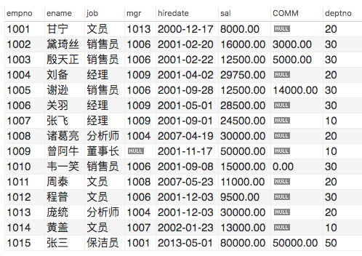
insert into EMP (EMPNO, ENAME, JOB, MGR, HIREDATE, SAL, COMM, DEPTNO) values (7369, 'SMITH', 'CLERK', 7902, str_to_date('17-12-1980', '%d-%m-%Y'), 800,null,20);
insert into EMP (EMPNO, ENAME, JOB, MGR, HIREDATE, SAL, COMM, DEPTNO)values (7499, 'ALLEN', 'SALESMAN', 7698, str_to_date('20-02-1981', '%d-%m-%Y'),1600, 300, 30);
insert into EMP (EMPNO, ENAME, JOB, MGR, HIREDATE, SAL, COMM, DEPTNO)values (7521, 'WARD', 'SALESMAN', 7698, str_to_date('22-02-1981', '%d-%m-%Y'),1250, 500, 30);
insert into EMP (EMPNO, ENAME, JOB, MGR, HIREDATE, SAL, COMM, DEPTNO)values (7566, 'JONES', 'MANAGER', 7839, str_to_date('02-04-1981', '%d-%m-%Y'),2975, null, 20);
insert into EMP (EMPNO, ENAME, JOB, MGR, HIREDATE, SAL, COMM, DEPTNO)values (7654, 'MARTIN', 'SALESMAN', 7698, str_to_date('28-09-1981', '%d-%m-%Y'),1250, 1400, 30);
insert into EMP (EMPNO, ENAME, JOB, MGR, HIREDATE, SAL, COMM, DEPTNO)values (7698, 'BLAKE', 'MANAGER', 7839, str_to_date('01-05-1981', '%d-%m-%Y'),2850, null, 30);
insert into EMP (EMPNO, ENAME, JOB, MGR, HIREDATE, SAL, COMM, DEPTNO)values (7782, 'CLARK', 'MANAGER', 7839, str_to_date('09-06-1981', '%d-%m-%Y'),2450, null, 10);
insert into EMP (EMPNO, ENAME, JOB, MGR, HIREDATE, SAL, COMM, DEPTNO)values (7788, 'SCOTT', 'ANALYST', 7566, str_to_date('19-04-1987', '%d-%m-%Y'),3000,null, 20);
insert into EMP (EMPNO, ENAME, JOB, MGR, HIREDATE, SAL, COMM, DEPTNO)values (7839, 'KING', 'PRESIDENT', null, str_to_date('17-11-1981', '%d-%m-%Y'),5000,null, 10);
insert into EMP (EMPNO, ENAME, JOB, MGR, HIREDATE, SAL, COMM, DEPTNO)values (7844, 'TURNER', 'SALESMAN', 7698, str_to_date('08-09-1981', '%d-%m-%Y'),1500, 0, 30);
insert into EMP (EMPNO, ENAME, JOB, MGR, HIREDATE, SAL, COMM, DEPTNO)values (7876, 'ADAMS', 'CLERK', 7788, str_to_date('23-05-1987', '%d-%m-%Y'),1100,null, 20);
insert into EMP (EMPNO, ENAME, JOB, MGR, HIREDATE, SAL, COMM, DEPTNO)values (7900, 'JAMES', 'CLERK', 7698, str_to_date('03-12-1981', '%d-%m-%Y'),950,null, 30);
insert into EMP (EMPNO, ENAME, JOB, MGR, HIREDATE, SAL, COMM, DEPTNO)values (7902, 'FORD', 'ANALYST', 7566, str_to_date('03-12-1981', '%d-%m-%Y'),3000,null, 20);
insert into EMP (EMPNO, ENAME, JOB, MGR, HIREDATE, SAL, COMM, DEPTNO)values (7934, 'MILLER', 'CLERK', 7782, str_to_date('23-01-1982', '%d-%m-%Y'),1300,null, 10);

